Hadham Hopper

Guide to Timings



Every Thursday from
Much Hadham, Perry Green and Green Tye to
Bishop’s Stortford Town Centre.
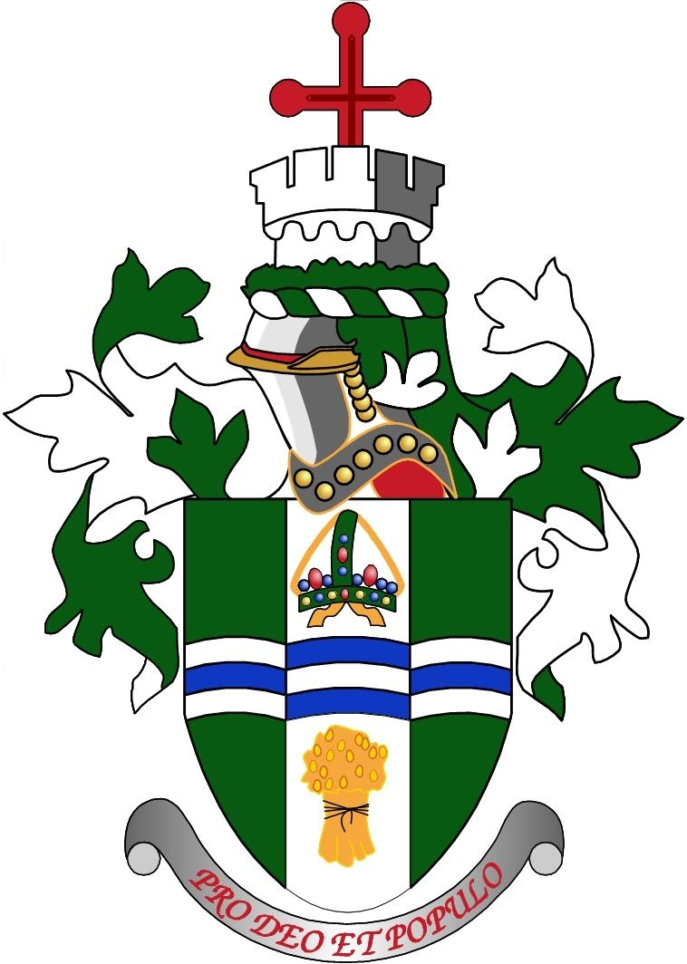

Hadham Hopper to
Bishop’s Stortford
Every Thursday from Much Hadham, Perry Green and Green Tye
to Bishop’s Stortford Town Centre

From Much Hadham, Perry Green and Green Tye to Bishop’s Stortford Town Council.

Bishop’s Stortford Minibus Trust in association with Bishop's Stortford Town Council and East Herts District Council operates a FREE service from Much Hadham, Perry Green and Green Tye to Bishop’s Stortford Town centre every Thursday.

All WELCOME!!

For further information please contact Bishop’s Stortford Town Council on 01279 715 004
OUTWARD
9:55am Broadfield Way, Much Hadham

10:10am St Elizabeth’s Centre, Perry Green

10:13am Main road, Perry Green

10:15amPerry Green opposite the Church

10:18amMain road, Green Tye

10:30amSouth Street (Methodist Church) Bishop’s Stortford
10:40amNorth Street (Lloyds TSB)
Bishop’s Stortford
10:50amJackson Square (Shopmobility) Bishop’s Stortford

RETURN
1:00pmJackson Square (Shopmobility)Bishop’s Stortford

1:20pmMain road, Green Tye

1:25pmPerry Green opposite the Church

1:30pm Main road Perry Green

1:35pmSt Elizabeth’s Centre, Perry Green

1:50pm Broadfield Way, Much Hadham

Guide To Timings

